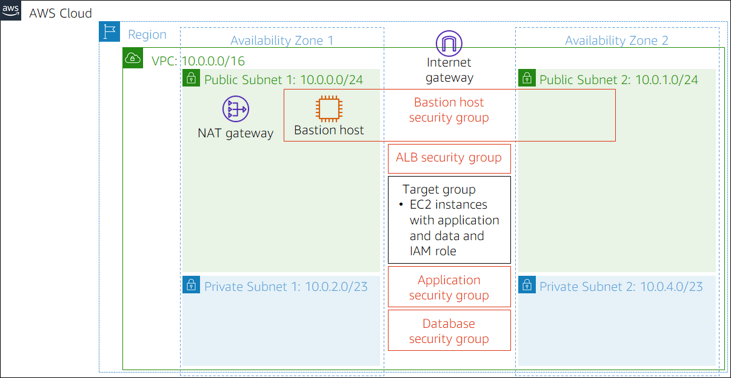

AWS Academy Cloud Architecting 2.x - Capstone Project

Project overview

This project provides you with an opportunity to demonstrate the solution design skills that you develop throughout this course. Your assignment is to design and deploy a solution for the following case. To help you complete this project, you will have continuous access to this development environment. The work that you add to your environment is preserved between sessions, so you can continue to develop your solution as you progress through the course materials.

By the end of this project, you should be able to apply the architectural design principles that you learned in this course to:

* Deploy a PHP application that runs on an Amazon Elastic Compute Cloud (Amazon EC2) instance
* Create a database instance that the PHP application can query
* Create a MySQL database from a structured query language (SQL) dump file
* Update application parameters in an AWS Systems Manager Parameter Store
* Secure the application to prevent public access to backend systems

Introducing the Example Social Research Organization

Example Social Research Organization is a (fictitious) nonprofit organization that provides a website for social science researchers to obtain global development statistics. For example, visitors to the site can look up various data, such as the life expectancy for any country in the world over the past 10 years.

Shirley Rodriguez, a researcher at the organization, developed the website. She thought it would be valuable to share the data that she had gathered with other researchers. Shirley stores the data in a MySQL database, and the data is available through a PHP website that she built. She initially published the site through a commercial hosting company that provides limited support for technical issues and security.

Over the past year, Shirley’s website has grown in popularity. As a result of increased traffic, she started receiving complaints that the site is not as responsive as it used to be. She also experienced an attempted ransomware security breach. The security breach was unsuccessful, but her supervisor, Mateo Jackson, suggested that Shirley investigate new ways to host the website.

Shirley heard about Amazon Web Services (AWS), and initially moved her website and database to an EC2 instance that runs in a public subnet. She also runs an instance of MySQL on the same EC2 instance.

Shirley approached your team to make sure that her current design follows best practices. She wants to make sure that she has a robust and secure website. One of your colleagues started the process of migrating the site to a more secure implementation, but they were reassigned to another project. Your tasks are to complete the implementation, make sure that the website is secure, and confirm that the website returns data from the query page.

The following summary lists the solution requirements, and provides a diagram of the current environment.

### **Solution requirements**

* Provide secure hosting of the MySQL database
  + **Capstone-DB**
  + **database1 password**
  + **Put in example VPC because it matches what’s in the diagram and already set up**
  + **In ALB SG and Bastion SG**
  + **No public access**
  + **In US East1a availability zone**
  + 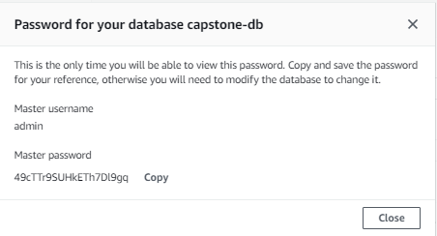
  + 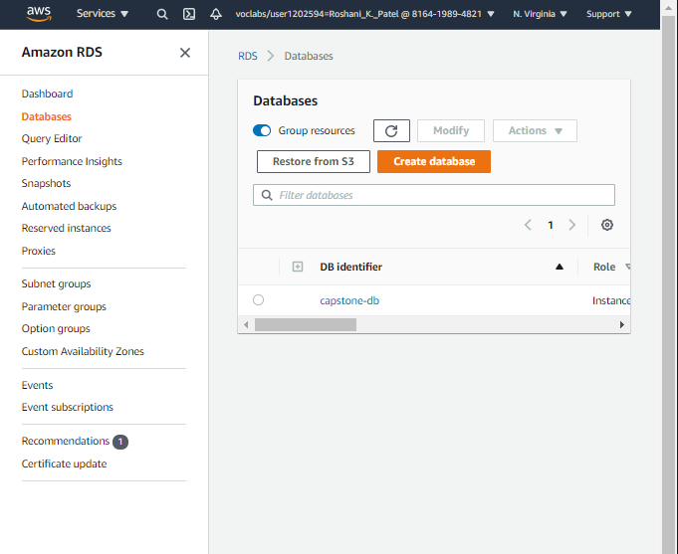
* Provide secure access for an administrative user
  + **Done, see above password created for database db**
* Provide anonymous access to web users
  + EC2 in private subnet connected to a Bastion Host SG only
  + Separate keys for Bastion Host and EC2 instance
  + 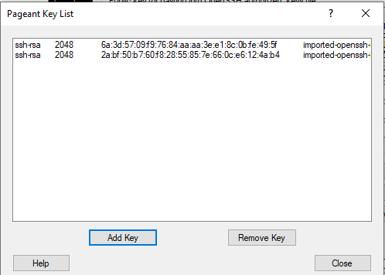
* Run the website on a t2.small EC2 instance, and provide Secure Shell (SSH) access to administrators
  + EC2 instance using t2.small
  + SSH access given
  + 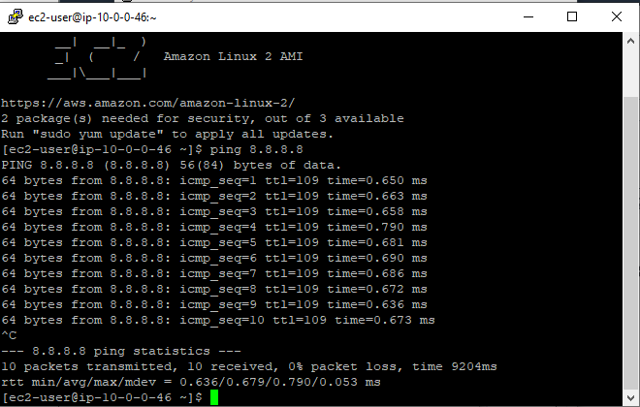
  + Website working:
  + 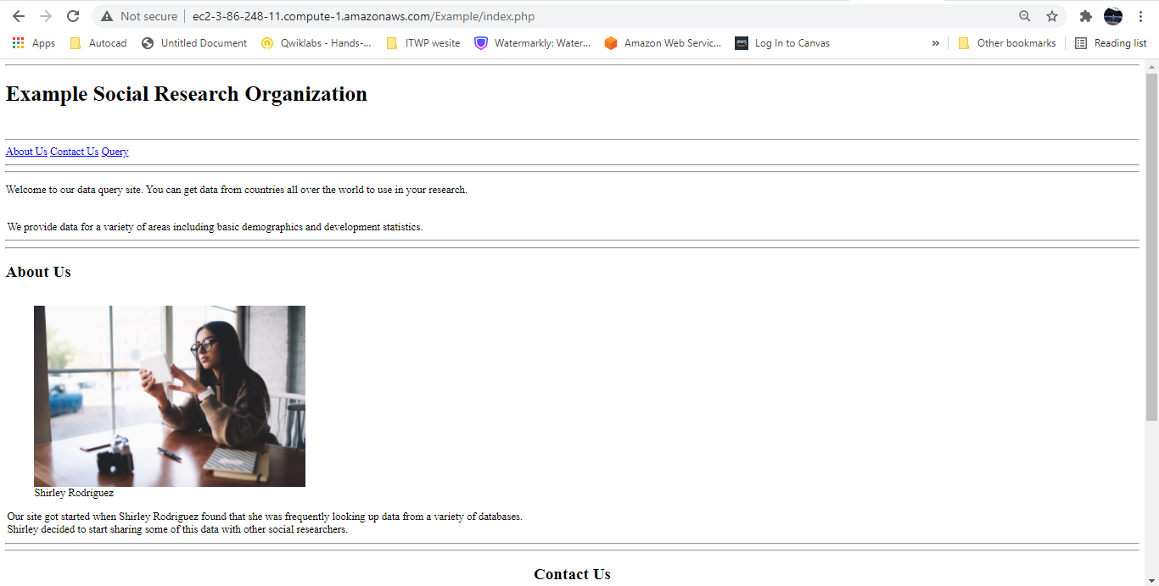
* Provide high availability to the website through a load balancer
  + Created a load balancer in the private subnet that connects to the EC2 instances and automatically balances traffic
* 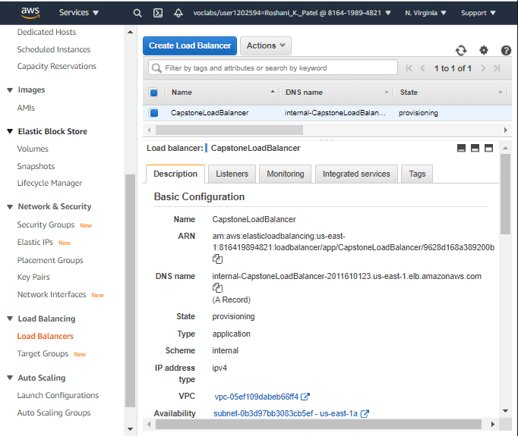
* Store database connection information in the AWS Systems Manager Parameter Store
  + Parameters created in Parameter store
* 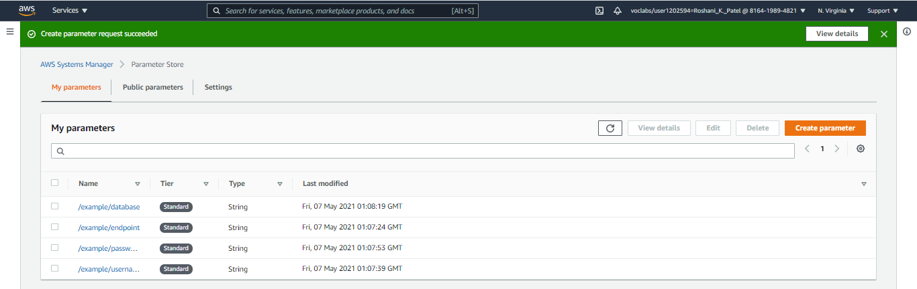
* Provide automatic scaling that uses a launch template

The following parameters are used by the PHP application to connect to the database:

* /example/endpoint
* /example/username
* /example/password
* /example/database

**These parameter values are case sensitive**.

## Project deliverables

To complete this assignment, you must:

* Deploy a PHP application that meets the system requirements outlined above
* Submit a diagram that illustrates your solution
* Submit a written summary of the design decisions that you made to achieve the result

**Written Summary:**

This capstone is hosting a web application on an EC2 server which is also connected to an SQL database. My solution for this is simple:

* Use the Example VPC Given for everything (10.0.0.0/16). Inside the VPC are two availability zones
  + A private and public subnet in each zone
  + The private subnet connects to a NAT Gateway which allows internet access
* Database Hosting: Host the database using Amazon RDS MariaDB Database
  + Connect via TCP Port 3306 via the Example DBSG
  + Password protected for administrator access
* Security
  + Database and EC2 instance hosting the website are in private subnet
  + EC2 instance connects to Bastion Host via TCP Port 22 (Bastion SG)
  + Various security groups
* Availability
  + EC2 instances in 2 regions with a load balancer
  + 2 Bastion Hosts in 2 regions

mysql -u username -p database_name < file.sql